XC-240/280L

Blood Bank Refrigerator

Operation Manual

Thank you for buying a blood bank refrigerator !

For your personal safety and better performance of this unit, please read this Operation Manual thoroughly and save it properly for future reference.

Failure to read, understand and follow the instructions in this manual may result in damage to the unit, injury to operating personnel and poor equipment performance.

Always use the proper protective equipment (clothing, gloves, goggles etc.).

Always follow good hygiene practices.

Each individual is responsible for his or her own safety.

 Safe Notice
- Please read this manual carefully when use our machine at the first time.
- The one who operate blood bank refrigerator should be trained and authorized.
- The better to use the original fittings
- Should be check-up and maintenance to blood bank refrigerator at the stated time.
- Blood bank refrigerator prohibit to storing alive life, flowers and others which not be fit for the low temperature.
- When blood bank refrigerator working, the inner temperature is very low. So if not wear glove, Please don’t touch the cover board.
- If the power shut off，Please wait 5minutes.Can to connect again, to prevent the compressor damage.

Content
1.Schematic Picture and Description 1
2.Pre-Installation 3
3.Operation Direction 4
3.1 Function Introduction for Display Panel 4
3.2 First Use 5
3.3 Functions Setting 6
4.Defrost ●Unused ● Maintenance 6
5 Service after sale 7
6 Specifications 8
6.1 Main parameter 8
6.2 Package List： 8

Schematic Picture and Description
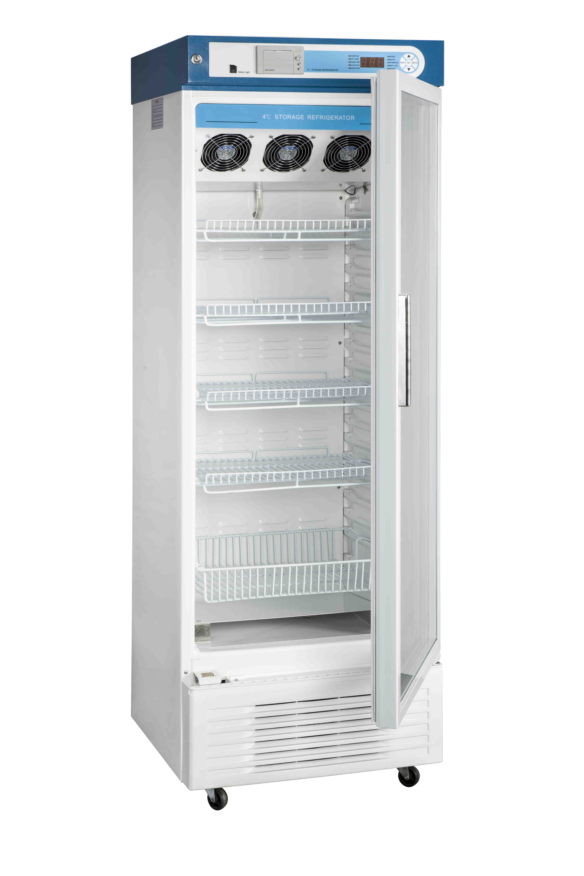
Control panel

Temperature Recorder
（optional）
Standard is printer

Door
Cabinet

Because the freezer amelioration and the model different, the actual product may not the same as the photo, Please follow the actual refrigerator.

Series of blood bank refrigerator is designed to store materials under very low temperature condition for hospital, epidemic station, blood bank, research institute, university, biological pharmaceutical industry and gene engineering, etc. The internal temperature in cabinet can be easily adjusted through the keys in control panel. All operations are convenient and reliable.

2. Pre-Installation
- How to transport：Pick up the unit from the bottom of tank and a slant plane within 45° is acceptable. All transportation should be carefully.
- Remove all wrappers.
- Check accessories and documents according to package list.
- Clean the unit thoroughly before any operation.
- Installing location：
- Do not position the unit in direct sunlight or near heating diffusers, radiators, or other sources of heat.
- The ambient temperature should be limited from 18-28℃. Or else should open the air-condition
- A minimum 30cm space on the sides, rear and top should be provided for better air circulation and heat discharge.
- Location where is too cold and place with high humidity or can be easily splashed by water are forbidden.

Safety Introduction
- Power supply：This freezer is designed operating under 110V/60HZ AC power supply. The unit can normally start under the voltage varying from 100V to 122V.
- Must provide one single exclusive plug receptacle with credible grounding to unit. Don’t lengthen the line randomly. If you need, Please use 2.5mm2 copper line,you should keep 4mm2 line to connect the electrical outlet.
- Inflammable and explosive materials, as well as high corrosive acid and alkali must be strictly prohibited in cabinet.
- Keep the key properly avoiding the children take it to open the back door which may result in unexpected injury.
- Keep the lamp off in use for saving energy sources and stabilization temperature in cabinet.

The machine working condition:

The environment temperature：18℃～28℃
The relative humidity：≤80%
No strong shake and causticity gas around.
No sunshine and other cold/hot power effect.

3.Operation Direction

3.1 Function Introduction for Display Panel
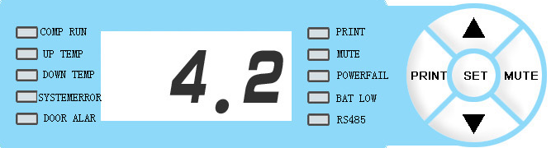

1. LCD code display window. The window displays the real-time internal temperature of refrigerator with unit ℃ under normal running condition, and displays different hint string under set condition: （Refer follows for details）
4.2
2. COMP RUN：Light for compressor work
3 .UP TEMP：Light for Numeral tube show the up temperature
4. DOWN TEMP：Light for Numeral tube show the down temperature
5. SYSTEM ERROR：Light for sensor failure and other abnormal
6. DOOR ALAR：The time of door open more than 1monite,the alarm system start.
※7. PRINT：The function will work after you equipped the printer.；
8. MUTE: Press this key to stop alarm buzzing.
9.POWERFAIL：Light for power failure(if the refrigerator with back-up battery)
※10.BAT LOW：Light for low battery
※11. RS485：Optional for remote control system.
12. “▲” 、“ ▼ ”： Function adjustment pads
13.“SET”： Press this key to set the function adjustment parameter;

3.2 First Use
- Connect the power supply and switch the on-off on the back of freezer working status；
- Set temperature: the default temperature is set as 4℃ in factory. Please don’t set any other temperature value.
3. “LTL”： When the actual temperature is lower 2℃ than the low temperature limit (LTL) setting, The code is LO
4. “HTL”: When the actual temperature is higher 7℃ than the low temperature limit (LTL) setting, The code is HI. (During the initial start-up, a “HTL” alarm is normal operation. After the temperature is stabilized and the “HTL” alarm stops you can put goods in your freezer);
5. upper Probe: show the upper cabinet temperature.
6. Lower probe: show the lower cabinet temperature.
7. Interior light
8. Sensor failure：Any sensor temperature ≤ or ≥50℃，Show E1，SYSTEM ERROR will light.
※9. When the rechargeable battery existences, when the power source supply disruption, the screen still lightened, showed the real-time cabinet temperature, recorded the number of door opening, LTL and HTL alarm. But the ventilator, the lamp and the refrigeration system does not work. (If the freezer has not been used for long time, the battery does not have electric quantity, it is normal that the window have no display. When freezer power source puts through, electrification completes automatically.)
Please close the power switch on the back of the box when the power cut for a long time( longer than three hours), otherwise the electric quantity loses and affects the battery service life!

3.3 Functions Setting
Time set：Press SET，Will show time set. N07 mean year 2007，then press“▲” or“▼”1 time to add or down the time(range from 01-99)，，SET confirmed and then show Y01，mean month 01，range from 01－12， Analogy like date R01，range from 01～29, S01 mean time 01， range from 01－12， F01 mean minute， range from 00～60 ，After Confirmed please back off.

Please don’t place the goods to wall up the fan wind hole, Or else will affect the chamber temperature.

4.Defrost ●Unused ● Maintenance

Unused：If the unit is not used for long time, please disconnect power supply and maintain as the following procedures. For next time operation, ensure there is not any water around the liners to avoid the seal of door is frozen.
Note：Any electric heater, metal tool or edge tool CAN NOT be used during defrost operation.
Note：DO NOT sprinkle water on the faces of cabinets, which may decrease insulating property of electric parts and rust metal parts.
DO NOT use hot water, corrosive cleanser and organic solvent!

Condition: Can not shake heavily, strike, prevent drench.

Environment Temperature: -40℃～+55℃, Relative humidity: 10％～90％.

5 Service after sale
Some unexpected failures may arise during running. Please pay attention to the running status of your freezer. If any exceptional case arises, please check and solve it according to the following introductions. If the problem is not solved well, please contact our service center for details.

Problem | Possible Cause
ULT freezer does not operate | - Power outage has occurred.  - The plug is bad or not securely plugged-in.  - Fuse is blown.  Voltage is too low or too high.
Compressor does not work | - Power in control panel is off.  - Temperature setting is wrong.
Temperature is higher than setting | - Frost in inner wall is too thick  - The door is not closed properly or is opened too frequently.  - Overfull materials are put into chamber.  - Ambient temperature is too high.
Too great noise | - Refrigerator is not leveled well.  - Refrigerator leans upon the wall.
Below are normal operation：
- There are some light clashes when the compressor starts up and stops.
- During rainy and watery season some frost may accumulate on the surfaces of cabinets. Please clean it with dry rag.

6 Specifications

6.1 Main parameter
Model | XC-240/280L | Safety Type | I Class B type
Climate Type | 18～28℃ | Rated Power（W） | 480
Internal Temp. | 4(±1)℃ | Refrigerant | R134a/150g
Valid Capacity（L） | 240/280 | Exterior Dimensions （L×W×H）（mm） | 615x603x1620/1873
Rated Voltage（V～） | 110 | Rated Power（Hz） | 60

6.2 Package List：
Name | Operation Manual | Key
Amount | 1 | 2

Circuit Diagram
